**Spectral Capital Announces Transformation into a**

**Deep Quantum Technology Platform**

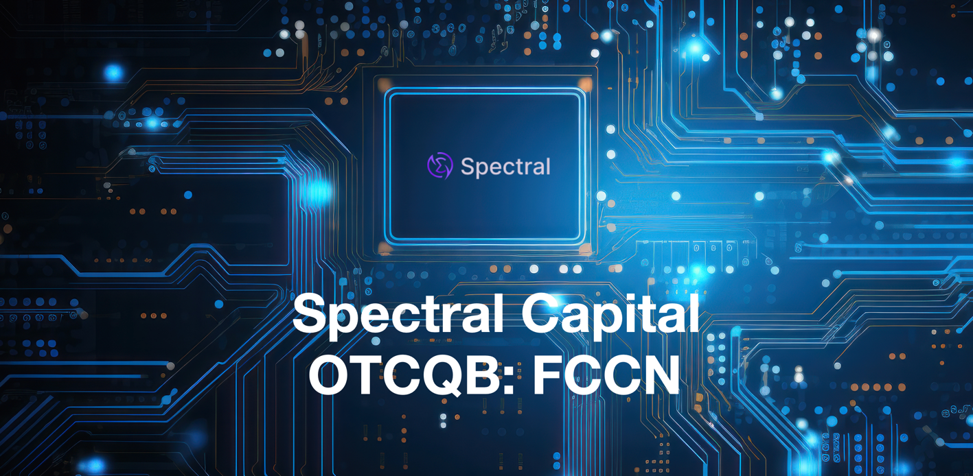

*Seattle, WA—December 24, 2024* — [**Spectral Capital Corporation**](https://www.spectralcapital.com/)[**(OTCQB: FCCN)**](https://www.marketscreener.com/quote/stock/SPECTRAL-CAPITAL-CORPORAT-120789102/), a leader in quantum innovation, proudly announces its transformation into a Deep Quantum Technology Platform. This strategic evolution positions Spectral at the forefront of the quantum era, uniting proprietary technologies in quantum cloud computing, distributed quantum ledger databases, and plasmonic quantum chips.

With the addition of renowned quantum physicist Dr. Moshik Cohen as Chief Technology Officer and the groundbreaking Verdant Quantum initiative, Spectral Capital is pioneering scalable, sustainable, and practical quantum computing solutions.

**From Incubator to Operator: Spectral’s New Vision**

Spectral Capital has redefined its role in quantum technology by moving beyond incubation to develop, own, and operate its proprietary quantum systems.

“This is not just a rebranding—it is a bold leap into the future of quantum computing,” said Jenifer Osterwalder, CEO. “Spectral Capital is now delivering a fully integrated platform with technologies like the [**Vogon Decentralized Edge and Hybrid Cloud**](https://www.spectralcapital.com/vogon), its embedded Distributed Quantum Ledger Database (DQLDB), plasmonic System-On-a-Chip (SOC) architecture, and energy-efficient quantum algorithms. These innovations bridge the gap between classical and quantum systems, offering the scalability and environmental responsibility required for the quantum era.”

**Introducing Room Temperature Quantum Transfer and Compute**

To drive its ambitious vision, Spectral announced earlier this month the addition Dr. Moshik Cohen, an expert in quantum state dynamics and plasmonic computing as CTO. The Company is fusing the revolutionary initiative from Verdant Quantum to eliminate the need for cryogenic cooling by leveraging room-temperature plasmonic chips.

This solution bridges classical and quantum computing with CMOS-compatible plasmonic processors allowing these chips harness energy waves controlled by light, called plasmons, to deliver near-light-speed data processing with unmatched precision and efficiency—all while dramatically reducing energy consumption and costs.

**Transformative Innovations Powering Spectral’s Platform**

The world’s first plasmonic-ready distributed quantum ledger database, Vogon, provides secure, scalable, and semantically enriched data management. Its key features include:

* Deterministic Concurrency for low-latency performance.
* Post-Quantum Cryptography with SPHINCS+ for unparalleled security.
* Consensus Algorithms to ensure robust and scalable decentralized operations.

The Vogon DQLDB seamlessly connects legacy systems to quantum ecosystems, enabling industries such as finance, logistics, and healthcare to harness quantum efficiencies today.

**Plasmonic System-On-a-Chip (SOC)**

Spectral’s miniaturized plasmonic SOC technology redefines the potential of its Vogon Cloud data centers, enabling near-light-speed processing at room temperature. These chips will power Spectral’s edge and hybrid compute data centers across 16 global regions, which will also serve as test beds for sustainable quantum computing.

“This innovation addresses the global call for environmentally friendly quantum solutions, reducing infrastructure costs while increasing processing power,” Brehm emphasized.

**Quantum Algorithms and Collective Intelligence**

Spectral’s proprietary quantum algorithms leverage cooperative distributed inferencing and analytic tomography to unlock real-time insights. By integrating these algorithms with Vogon DQLDB, Spectral enables industries to optimize operations, from autonomous vehicles to investment portfolio management.

**Why Spectral Capital?**

The quantum computing market is projected to grow from $885.4 million in 2023 to $12.62 billion by 2032, with a CAGR of up to 34.8%. Spectral’s technologies are poised to capture this growth while addressing urgent industry demands for scalable, cost-effective, and sustainable quantum solutions.

“Over the next decade, quantum computing will redefine the global economy,” said Brehm. “Spectral Capital is at the epicenter of this transformation. With Dr. Moshik Cohen, and our ecosystem partners, we are building not just for the future—we are building *the future*.”

**A Call to Visionary Investors**

Spectral Capital invites forward-thinking investors to join us in shaping the quantum revolution. With groundbreaking technologies and a commitment to sustainability, Spectral offers a unique opportunity to drive the next wave of global innovation.

**About Spectral Capital**

Spectral Capital Corporation (OTCQB: FCCN) is a Deep Quantum Technology Platform company delivering practical, scalable, and sustainable quantum solutions. Through its proprietary Vogon DQLDB, QuantumVM, and plasmonic SOCs, Spectral Capital is revolutionizing industries and paving the way for a more connected, efficient, and sustainable world.

For more information, visit [www.spectralcapital.com](http://www.spectralcapital.com) or contact our Investor Relations team at Rubenstein and Associates.

**Forward-Looking Statements**

This press release includes forward-looking statements that are subject to risks and uncertainties. Actual results may differ materially from expectations. Please review the company’s filings for a full risk assessment.